Diagnostic Analysis Report: McDonald's Nutrition
Prepared by: Sauravi Sarode
Batch / Team: PTID-CDA-SEP-26-11277
Date: 11-10-2026
Tool: MySQL and Power BI
Course project CDACL-004 Fast Food Analysis
Company analysed: McDonald's

1. Introduction
This project analyses the nutrition of menu items in a fast-food dataset covering 8 restaurant chains. I chose McDonald's as my company. The goal is not only to describe the numbers (descriptive analysis) but to explain why the numbers look the way they do (diagnostic analysis), and to give recommendations based on the evidence.

2. Dataset Description
- Source: a fast-food nutrition table in MySQL with 512 records and 8 restaurants.
- Columns used: restaurant, item, calories, cal_fat, total_fat, sat_fat, trans_fat, cholesterol, sodium, total_carb, fiber, sugar, protein, vit_a, vit_c and calcium.
- McDonald's subset: 57 menu items.
- Measures: calories, fats, cholesterol, sodium, carbohydrates, fiber, sugar and protein per item. Vitamins and calcium are percentages of the daily value.

Limitations
- There is no price column, so the "average price" mentioned in the project brief cannot be analysed. Nutrition measures are used instead.
- Vitamin A, vitamin C, calcium and fiber have missing values for some restaurants (not for McDonald's vitamins).
- The original salad column holds the value "Other" for every row, so it was not usable.
- The data has no portion weights or sales figures, so I cannot say which items customers actually buy.
- The results show relationships (correlation), not proof of cause.

3. Data Cleaning
- Removed satish (completely empty), age (all zeros) and salad (no information).
- Removed 1 duplicate Taco Bell rows (512 to 511 rows overall).
- Replaced the text value "NA" with null in fiber, protein, vit_a, vit_c and calcium, then set these columns to numeric types. Blanks were kept as blanks, not replaced with 0.
- Standardised restaurant names (for example Mcdonalds to McDonald's).
- Created new columns: Calorie Category (Low under 300, Medium 300 to 600, High over 600), Is Salad (from the item name) and Protein per 100 Cal.

4. Dashboard Overview
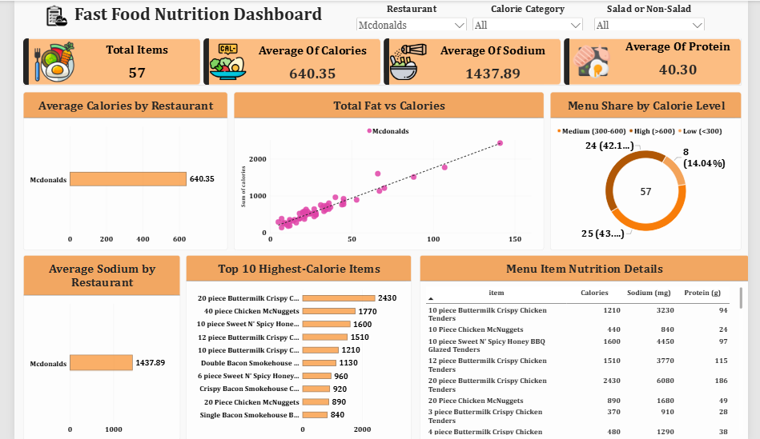

The dashboard has five KPI cards, filters (restaurant, calorie level, salad or non-salad) and charts that update together:
- Average Calories by Restaurant
- Total Fat vs Calories (scatter plot)
- Menu Share by Calorie Level (donut chart)
- Average Sodium by Restaurant
- Top 10 Highest-Calorie Items
- Menu Item Nutrition Details (table)
McDonald's headline numbers: 57 items, average 640.35 calories, average 1,437.89 mg sodium and average 40.30 g protein. For comparison, the average across all chains is about 531 calories, 1,247 mg sodium and 28 g protein, so McDonald's items are heavier and saltier but also much higher in protein.

5. Key Findings and Diagnosis
Each finding follows the same pattern: what I found, the evidence, the reason, and what it means.

Finding 1: A few very large items produce the extreme calorie values

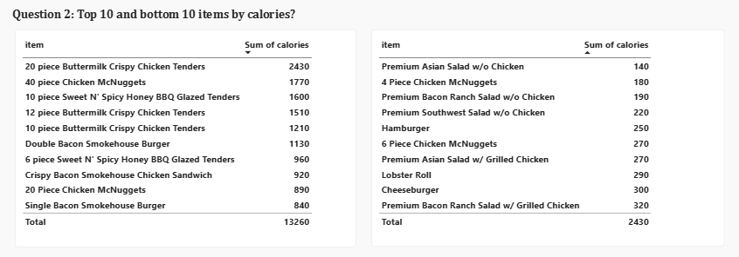

- Evidence: calories range from 140 to 2,430. The top items are the 20-piece Buttermilk Crispy Chicken Tenders (2,430), 40-piece Chicken McNuggets (1,770), 10-piece Sweet N' Spicy Honey BBQ Glazed Tenders (1,600), 12-piece Buttermilk Crispy Chicken Tenders (1,510) and 10-piece Buttermilk Crispy Chicken Tenders (1,210).
- Why: these are multi-piece sharing portions listed as one item, and they are breaded and fried. Five of the top ten are chicken pieces sold in large counts.
- Meaning: the average is pulled up by sharing items. A customer eating a single-serve item (for example a Hamburger at 250 or a Cheeseburger at 300) eats far fewer calories.

Finding 2: Sodium is very high, especially in fried chicken items

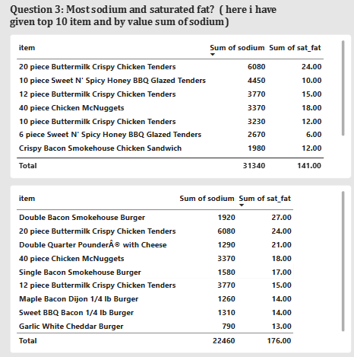
- Evidence: the highest sodium item is again the 20-piece tenders at 6,080 mg, followed by the 10-piece Sweet N' Spicy Honey BBQ Glazed Tenders (4,450 mg) and the 12-piece Buttermilk Crispy Chicken Tenders (3,770 mg). Six items exceed 2,300 mg (the commonly cited daily limit) and 19 items exceed 1,500 mg.
- Why: breading, seasoned coatings, sauces, cheese and processed meats all add salt, and large portions multiply it.
- Meaning: one item can supply more than twice the recommended daily sodium.

Finding 3: Saturated fat is highest in burgers and large tender portions
- Evidence: the highest saturated fat items are the Double Bacon Smokehouse Burger (27 g), 20-piece Buttermilk Crispy Chicken Tenders (24 g), Double Quarter Pounder with Cheese (21 g), 40-piece Chicken McNuggets (18 g) and Single Bacon Smokehouse Burger (17 g).
- Why: double beef patties, bacon and cheese are all high in saturated fat, which is why burgers with multiple layers rank at the top, even when their calories are lower than the 20-piece tenders.
- Meaning: an item can be a high-risk choice for saturated fat even if it is not the highest in calories, so sodium, saturated fat and calories should be judged separately.

Finding 4: Salads are much lighter than other items

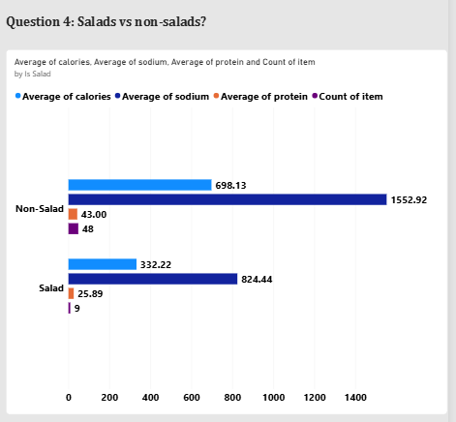
- Evidence: McDonald's has 9 salads and 48 non-salad items. Salads average 332 calories, 824 mg sodium and 26 g protein, while non-salad items average 698 calories, 1,553 mg sodium and 43 g protein.
- Why: salads replace buns, fries, fried coatings and cheese with vegetables, so calories and sodium are roughly halved. Protein is lower because there is less meat.
- Meaning: choosing a salad cuts calories and sodium by more than half, but toppings and dressings still matter.

Finding 5: Grilled chicken items give the best protein for their calories

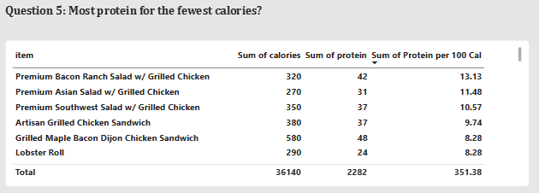
- Evidence: the best items by protein per 100 calories are the Premium Bacon Ranch Salad with Grilled Chicken (13.13, with 42 g protein for 320 calories), Premium Asian Salad with Grilled Chicken (11.48), Premium Southwest Salad with Grilled Chicken (10.57), Artisan Grilled Chicken Sandwich (9.74), and the Grilled Maple Bacon Dijon Chicken Sandwich and Lobster Roll (8.28 each).
- Why: grilled chicken is lean protein, and it avoids the breading and frying that add calories without adding protein.
- Meaning: these are the smartest nutritional choices on the menu.

Finding 6: Calories rise strongly with fat, sodium and protein

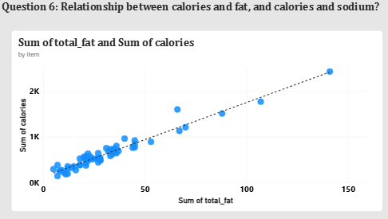
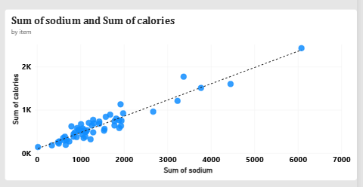
- Evidence: both scatter charts show points rising closely along the trend line. The correlation of calories with total fat is about 0.97, with sodium about 0.95 and with protein about 0.95.
- Why: fat has 9 calories per gram versus 4 for carbohydrates and protein, so fatty items gain calories quickly. Meat-heavy items bring fat, protein and salt together, so these measures rise at the same time.
- Meaning: reducing fat in an item is the most direct way to reduce its calories. Because sodium and fat move together, lowering one often lowers the other.

Finding 7: Almost half of the menu is high calorie

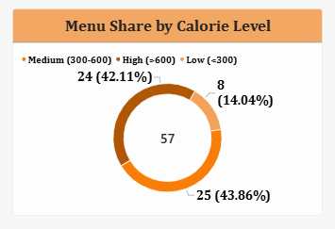
- Evidence: of 57 items, 8 (14.0%) are low calorie (under 300), 25 (43.9%) are medium (300 to 600) and 24 (42.1%) are high calorie (over 600).
- Why: the menu is built mainly around burgers, sandwiches and fried chicken, with few light options.
- Meaning: a customer has limited low-calorie choices, and nearly one item in two is above 600 calories.

6. Summary of Diagnostic Insights
- Large portions drive the highest calories and sodium.
- Frying, breading, cheese and bacon drive sodium and saturated fat.
- Fat content is the strongest driver of calories.
- Salads and grilled chicken are the lightest and highest-value choices for protein.
- The menu is heavy, with 42% of items above 600 calories.

7. Recommendations
- Separate sharing portions from single servings on menus and in nutrition reports, so averages are not distorted.
- Show a sodium warning on items above 1,500 mg, since 19 of 57 items exceed this level.
- Promote grilled options (grilled chicken salads and sandwiches) as the best protein-per-calorie choices.
- Add more light items under 300 calories, since only 8 of 57 items are in this group.
- Reduce fat in multi-patty burgers, for example with a lighter cheese or sauce option, to lower both calories and saturated fat.
- Collect price and sales data in future analysis, so nutrition can be connected to what customers actually buy and pay.

8. Conclusion
McDonald's menu has a wide range, from a 140-calorie salad to a 2,430-calorie sharing platter. The extremes come from large, fried, breaded portions, while the lightest and most nutritious choices are salads and grilled chicken items. Calories follow fat very closely, and sodium and saturated fat are concentrated in the same heavy items. With better labelling and more light options, customers could make healthier choices without losing variety. A limitation of this analysis is the lack of price and sales data, which would allow a deeper look at what customers choose.

